Proton X70 Navigation Map Update Method
(For End User)

Updated as of: 21st Oct 2021

Content
1. X70 Navigation map data update method 2
1.1 Online full map data update 2
1.2 Online routine map data update 6

X70 Navigation map data update method

Navigation of X70 map update method include:
- Online full map data update
- Online routine map data update

Online full map data update

Precondition：
Switch to Neusoft navigation from Baidu navigation and launch the navigation app. Since there is no offline map data in the car, map data for navigation will be downloaded from cloud (to ensure network is connected).
In this scenario, online full map data update will be triggered.

Update step：

Step 1:
Ensure the IHU can be connected to the Internet and wait for the IHU to be updated to the correct time (ensure time is correct).
Click the navigation APP, and the following page will be displayed (this page will only be displayed when there is no Neusoft offline map data in IHU). Then select "Download".

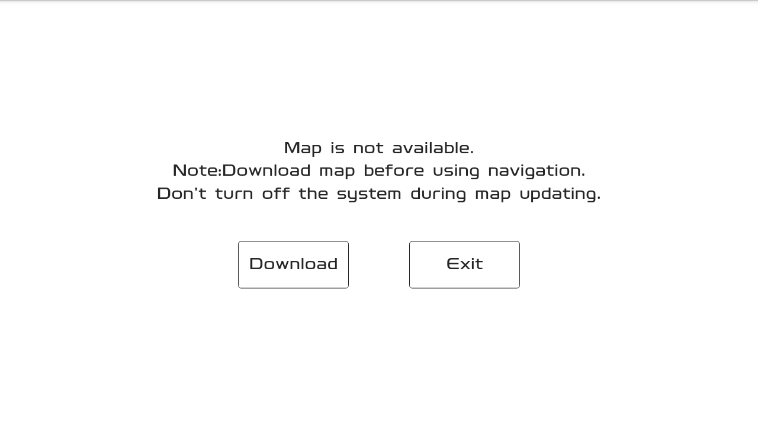

Step 2:
Once user clicked “download”, the screen will display download progress. Downloading process will normally take approximately 10 minutes or more depending on the user’s network connection.

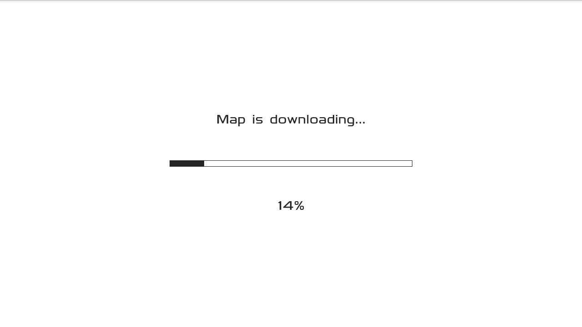

Step 3:
If the screen is not displaying download progress but “network connection failed” notification appeared, please check the following: -

- Please confirm the network connection of the car, Poor car network connection
- If network connection is stable, please click “Retry” to attempt download again,
- If you are unable to download after few attempts, click “Exit” and re-enter navigation app to retry
- the network connection is unstable, few attempts might be necessary to successfully start with the download
- If steps 1-4 do not resolve the issue, contact your nearest Proton dealer for further assistance.
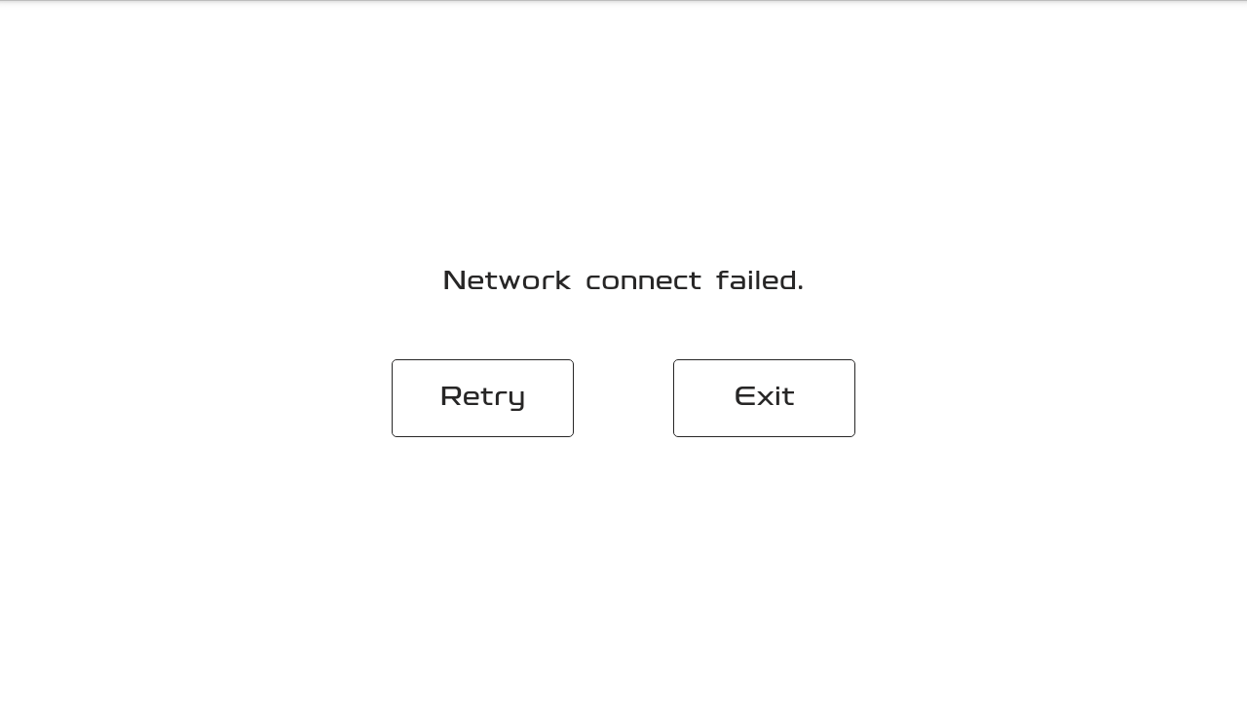
Step 4:
If you see “Map download failed” popup while downloading is in progress, please check the following: -
- Poor car network connection.
- If network connection is stable, please click “Retry” to attempt download again.
- If the network connection is unstable, few attempts might be necessary to successfully start with the download.
- If steps 1-3 do not resolve the issue, contact your nearest Proton dealer for further assistance.

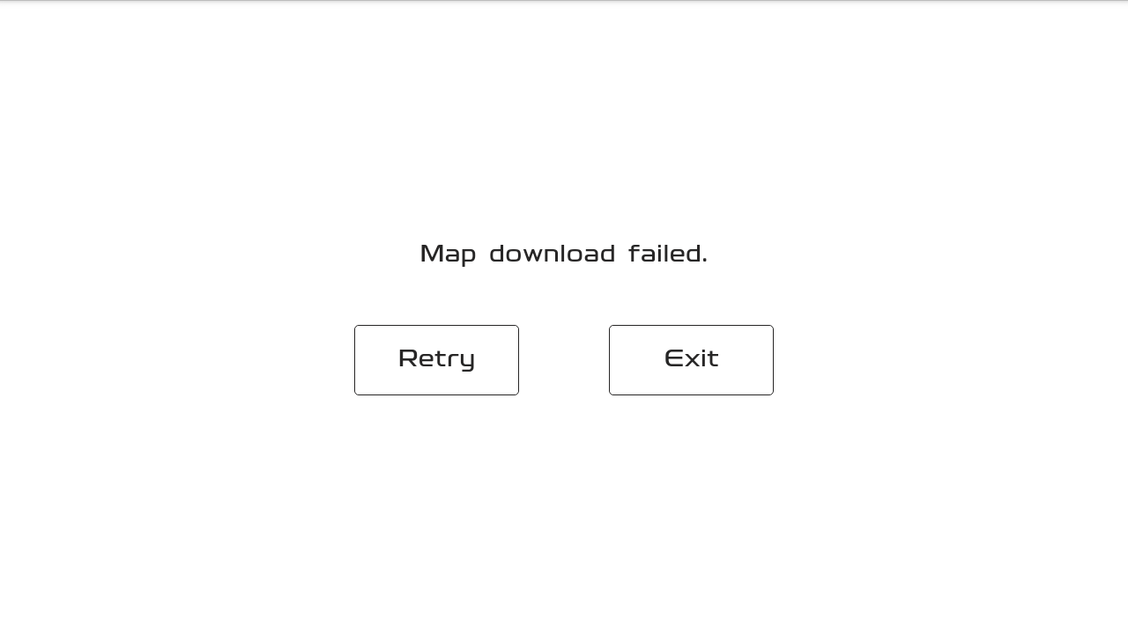

Step 5:
Download is successful once the download progress bar reaches 100%. Downloading process will normally take approximately 2 minutes or more depending on the user’s network connection.

Step 6:
If you see “Map update failed. Please contact dealer” notification appears while updating, please check the following:
- First please click “Confirm” to exit navigation APP and re-enter navigation APP to download again.
- After few failed attempts, please restore to factory settings and retry download.
- If steps 1-2 do not work, please contact Proton dealer.
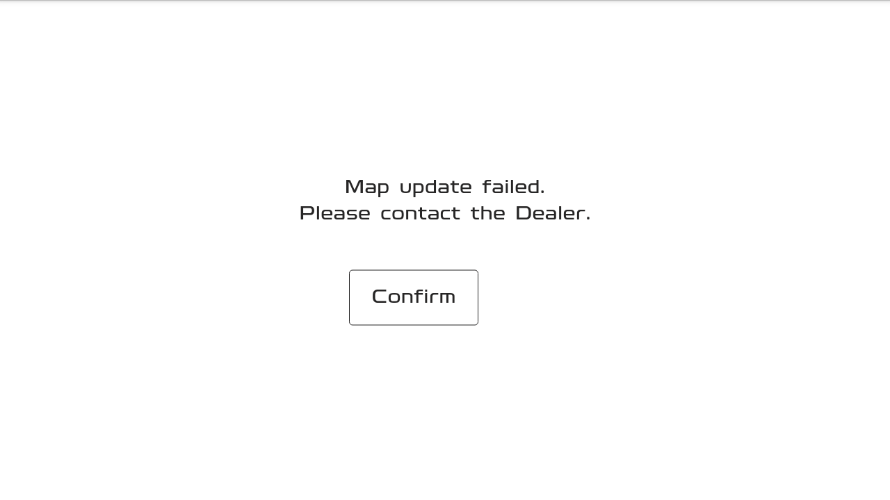
Step 7:
Once installation has been completed, “Map update complete” notification will pop up on the screen.

Click “Confirm” to exit navigation APP and re-enter navigation APP to use the updated map data.
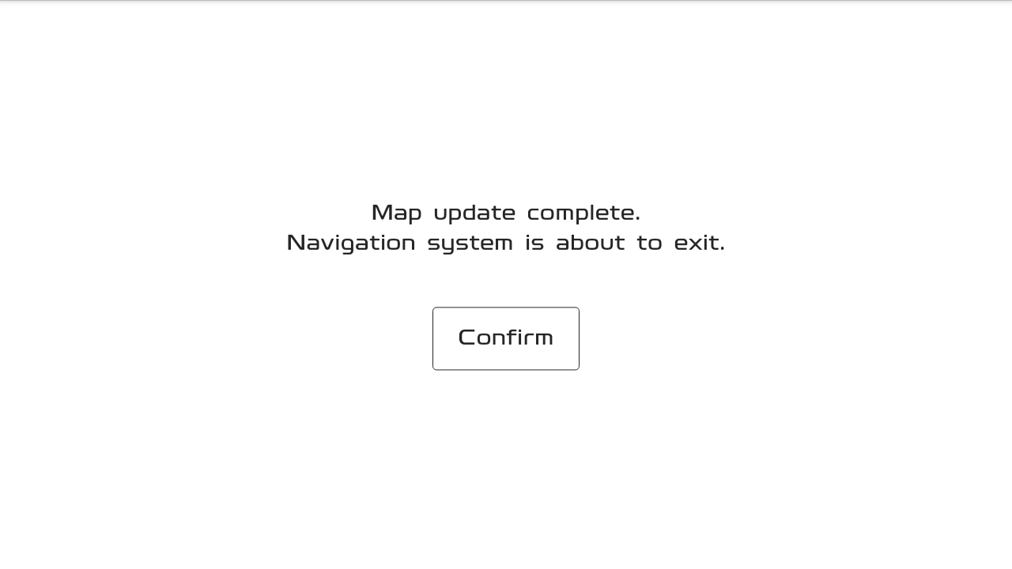
Start navigation APP and will enter the navigation activating screen (Please refer to Navigation document regarding activating description).

Online routine map data update

Precondition：
If the system detected obsolete offline map data in the IHU, the software would compare the map data version when there is a stable network connection. If a newer version is detected, it will automatically download new map data from the cloud in the background and update the old map data of the IHU.

Update step:

Step 1:
Upon entering the navigation, the system will automatically compare the map data version. If the cloud has a different version than of the IHU, the background map data download and update will start.
If “New navigation map available” popup appears, this means that the update is successful.

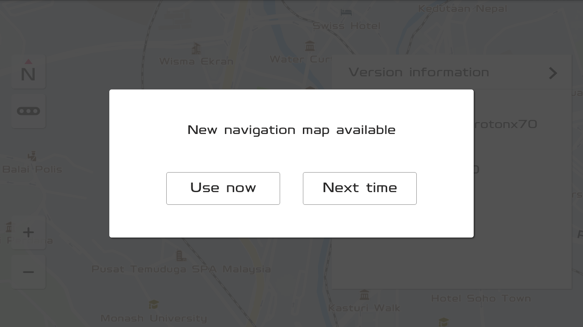
Note: Updating process will be done in the background and current navigation will function normally. If the update process is interrupted, the system will resume update once there is a stable network connection.

Step 2:
Click “Use Now” to start using the updated navigation version. You may confirm the map version from the navigation settings. You can enter the navigation activation page. For details, please refer to the description of activation in the previous navigation manual.
I.e., Before map update the map version is: N.P.B1.21.00.02.00

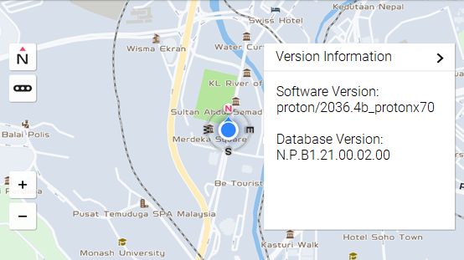

After update: Version N.P.B1.21.00.03.00

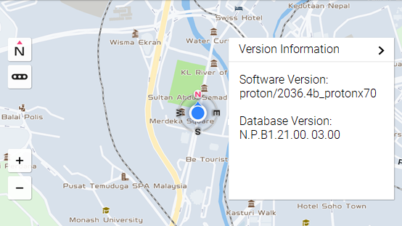

Step 3:
By selecting “Next time”, navigation will presume with the old map data. Updated map data will start when new navigation is entered.

